ADD PRIMARY & SECONDARY EMAIL FOR NEW PARTNER/CLIENT

STEP 1:

* Go to sales-> leads-> create new lead-> create new partner-> assign primary and secondary email

* Email (mandatory):: contains primary email

* “Do Not Send Email To Primary Address”(optional) : Mark this field to disable primary email during sending email to partner from odoo.

* Addtional contact information (optional): contains secondary email

* Mark “send email” field if email has to be sent on this address from odoo

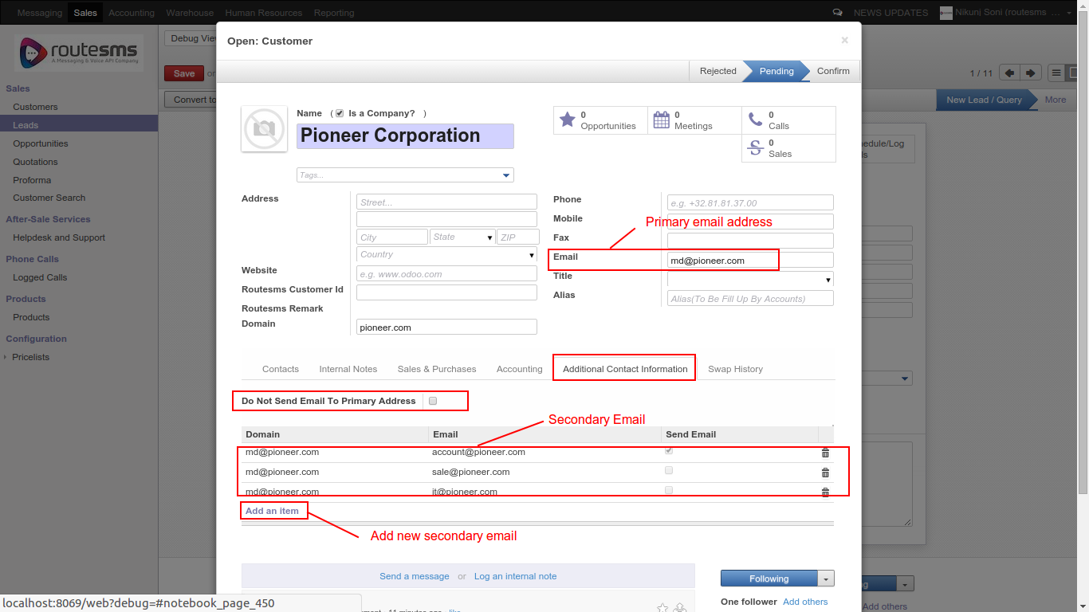

THANK YOU

